SUBCOURSE EDITION
IT0341 A

US ARMY INTELLIGENCE CENTER

ATOMIC STRUCTURE

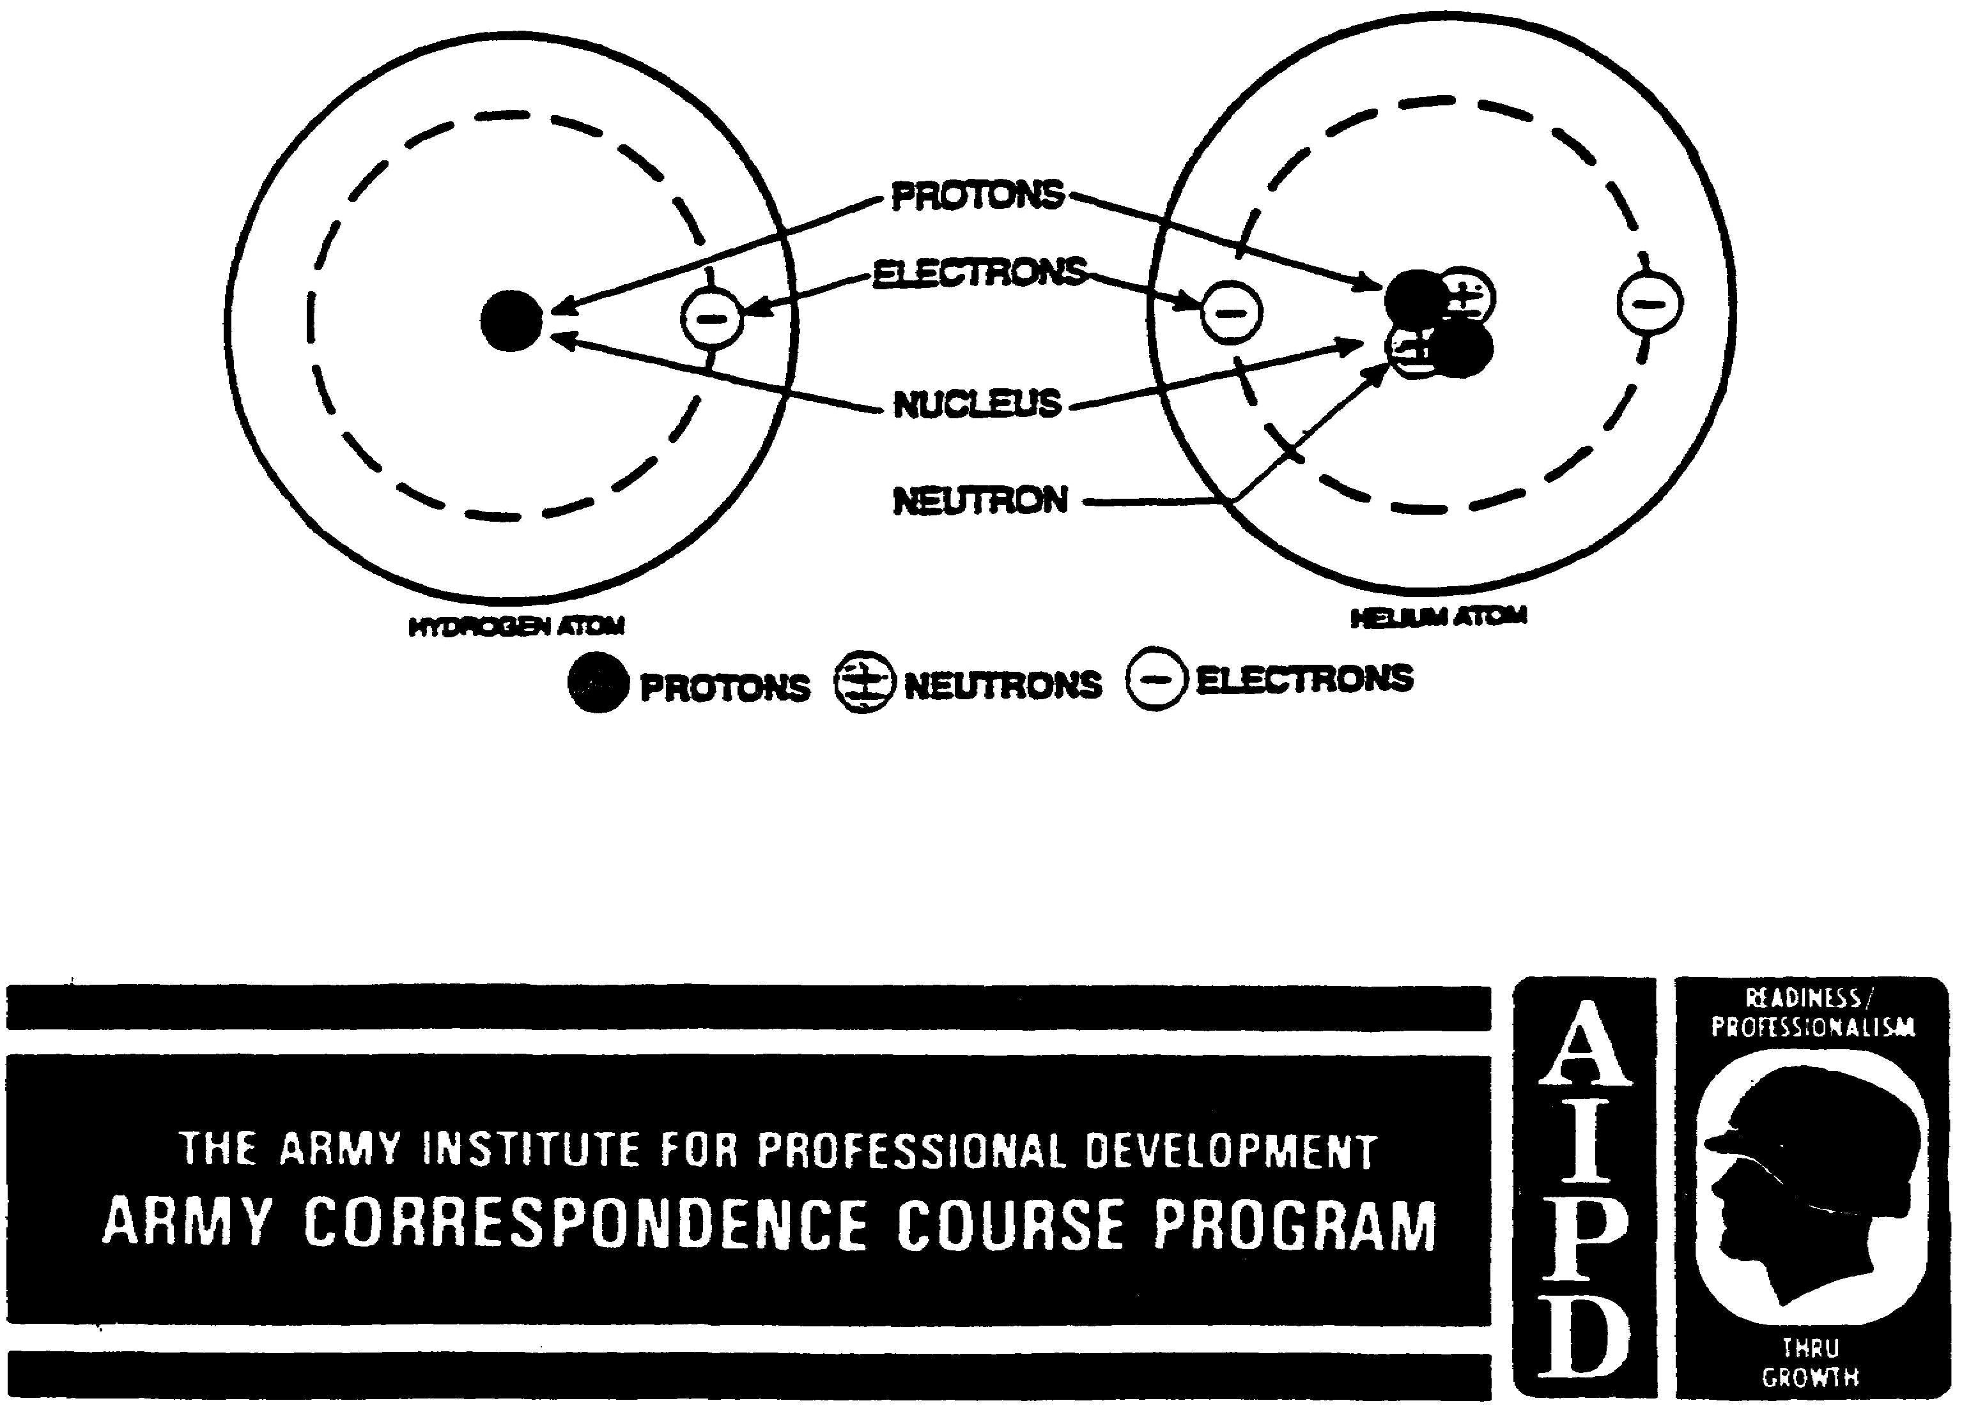

ATOMIC STRUCTURE

Subcourse Number IT0341

EDITION A

US. ARMY INTELLIGENCE CENTER
FORT HUACHUCA, AZ 85613-6000

2 Credit Hours

Edition Date: April 1996

SUBCOURSE OVERVIEW

This subcourse is designed to teach you the basic physical and chemical properties of atoms as they pertain to the study of electronics.

There are no prerequisites for this subcourse.

This lesson replaces SA 711.

TERMINAL LEARNING OBJECTIVE.

ACTION: You will be able to perform each of the following objectives:
- match the terms molecule, atom, element, conductor, semiconductor, insulator, mass number, atomic mass unit, relative atomic weight, isotope, and half life with their definitions.
- select the four main parts of an atom and indicate the charge of each part.
- determine the maximum number of electrons in a specified energy shell.
- solve for the maximum number of subshells within each main shell of an atom.
- be able to match the characteristics of an atom with its definition.
- determine characteristics of common elements by using the periodic chart.
- identify the requirements for chemical stability of an atom.
- match each of the three types of chemical bonding with its definition.
- recognize the effect that an increase in temperature has on the resistance of a conductor material.
- recognize the effect that an increase in temperature has on the resistance of a semiconductor material.
- identify the two types of isotopes occurring in nature.
- recognize a statement which describes mass defect.
- choose the three types of change that take place in matter.

CONDITION: Given correct and incorrect statements, characteristics, and definitions, and a periodic table of elements..

STANDARD: To demonstrate competency of this task, you must achieve a minimum of 70% on the subcourse examination.

i IT0341

TABLE OF CONTENTS

Section Page

Subcourse Overview i

Lesson 1-1

Periodic Table of the Elements 1-39

IT0341 ii

LESSON

ATOMIC STRUCTURE

CRITICAL TASK: None

OVERVIEW

LESSON DESCRIPTION:

Upon completion of this lesson, you will know the basic physical and chemical properties of atoms as they pertain to the study of electronics.

TERMINAL LEARNING OBJECTIVE:

ACTION: Identify basic physical and chemical properties of atoms.

CONDITION: Given the information provided in this lesson.

STANDARD: To demonstrate competency of this task, you must achieve a minimum of 70 percent on the subcourse examination.

REFERENCES: The material contained in this lesson was derived from the following publications: SA0711, Asimov, Isaac. How did we find out about atoms? (Walker, 1976) Berger, Melvin. Atoms, Molecules, and Quarks (Putnam, 1986). Mathias, Marilynne and Johnson, Robert Matter and energy (New Readers, 1983).

IT0341 iv

INTRODUCTION

An understanding of basic physical and chemical properties is essential to the study of electronics. Even the more complex electronic devices can be reduced to a study of electron behavior in solids or gases. To follow explanations for semiconductor devices, for example, the student must have a knowledge of how atoms bond together to make a crystal. It is the purpose of this program to provide the basic knowledge of atomic structure necessary for a further study of electronics.

It has been shown in a related lesson that matter (anything which has mass and occupies space) is not constructed randomly, but is composed of definite building blocks' arranged in an identifiable manner.

1. All matter is made up of either a single element or a combination (two or more) of elements. An element is a substance that cannot be broken down into a simpler substance by any chemical means. There are 92 known basic elements. In addition to the 92 naturally occurring elements, there are more than a dozen others that are not found in nature called transuranium elements. These elements are all made of atoms that have more mass than the uranium atom.

A molecule is the smallest particle of a substance that retains the characteristics of the substance.

Molecules are constructed of one or more atoms, the smallest particles of an element that retain the identity of the element. Molecules are held together by electrical forces between one or more electrons of one atom of another atom.

1-1 IT0341

1. (Continued)

To further understand the relations of elements, molecules, and atoms, study the illustrations
below.

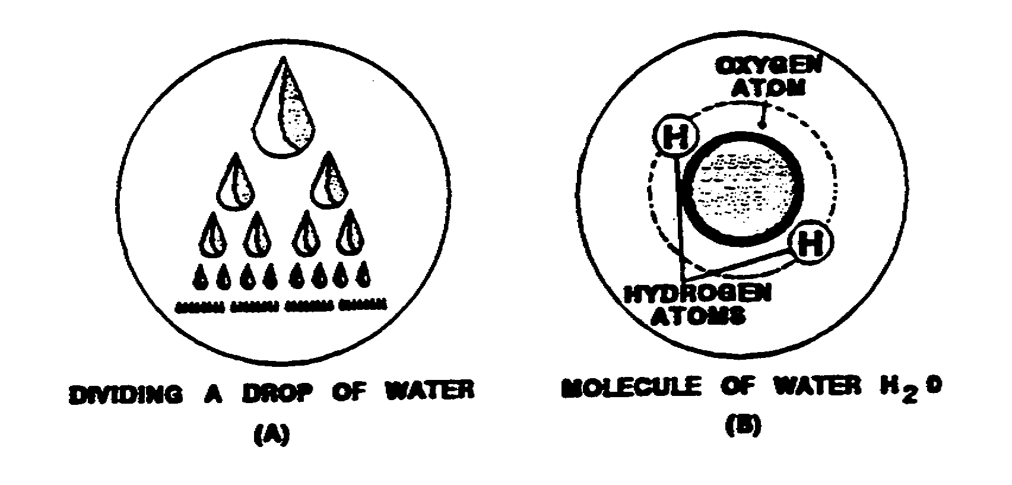

A molecule of water consists of three atoms of two different elements: two atoms of hydrogen and one of oxygen. If a molecule of water were broken down any further (into atoms), the characteristics of water would disappear, leaving only three atoms of two unrelated elements.

Match each term in column A with its definition in column B.

A B

____(1) Molecule. a. The smallest particle of an element that retains the identify of the element.

____(2 ) Element. b. The smallest particle of a substance that retains the characteristics of the substance.

____(3) Atom. c. A substance that cannot be broken down into a simpler substance by any chemical means.

IT0341 1-2

(1) b.  (2) c.  (3) a. | 2. Much has been learned about the inner structure of the atom in the last hundred years. So much is stiff theoretical that any attempt to portray the atom pictorially is to some extent a distortion. It is convenient to picture the atom as an orbital system, as in the figure below.  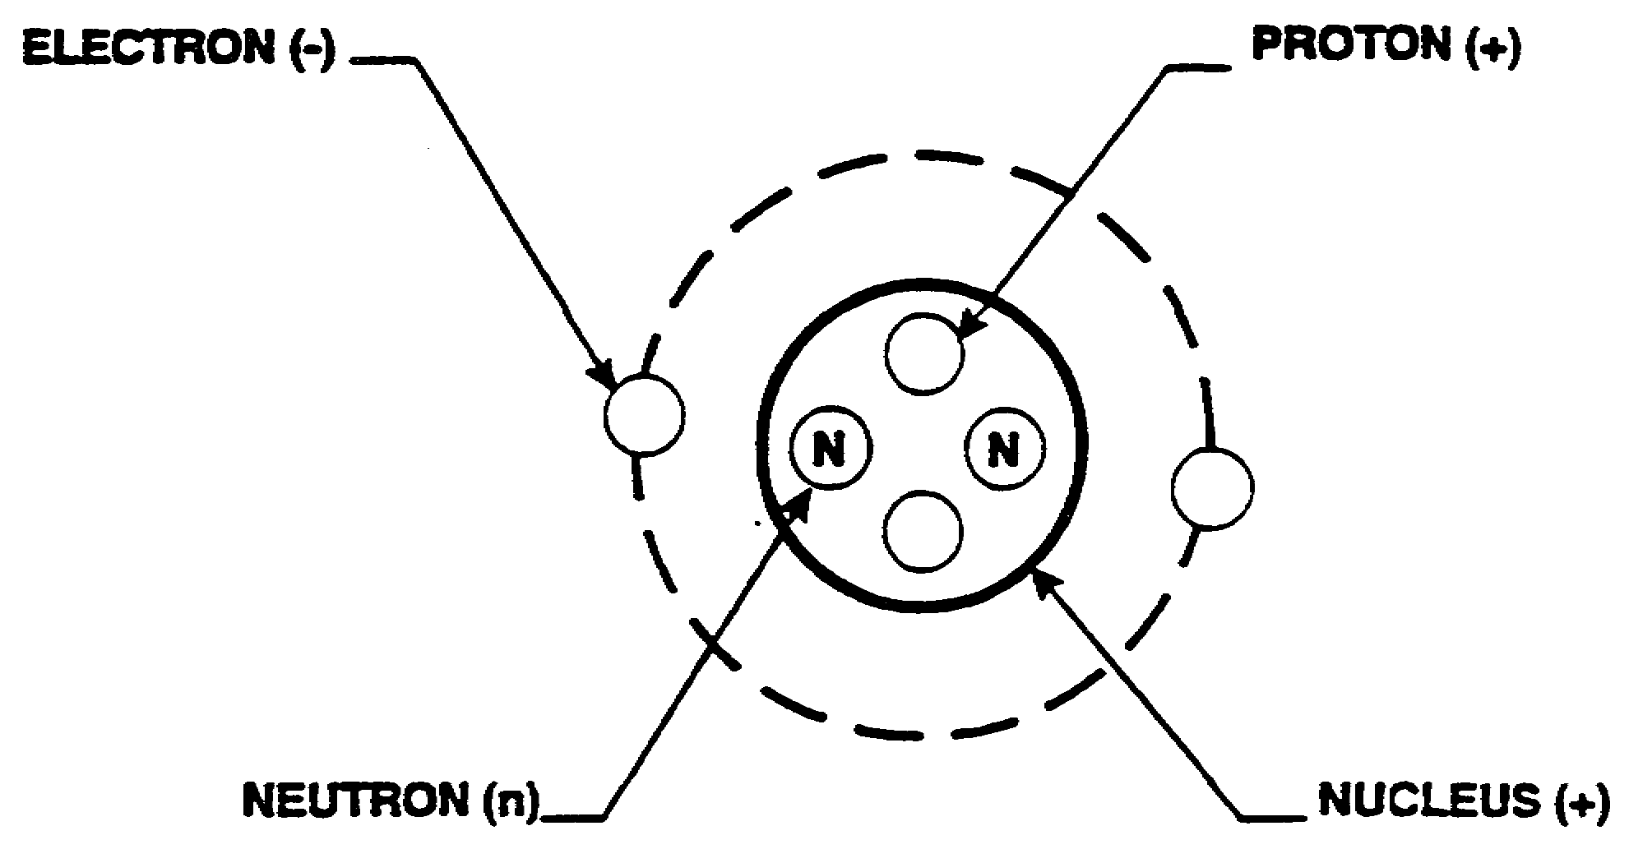  The NUCLEUS is an extremely small part of the atom, yet most of the mass is contained therein. The nucleus is made up of positively charged particles called PROTONS and particles called NEUTRONS with no (neutral) electrical charge. ELECTRONS, which orbit around the atomic nucleus, are about the same size as the nucleus but have smaller masses. The electrons are negatively charged. A neutral atom has the same number of electrons as protons, so the electrical charges cancel.

1-3 IT0341

2. (Continued)

Label the parts of the atom illustrated below and indicate the charge of each as positive (+), negative (-), or neutral (n).

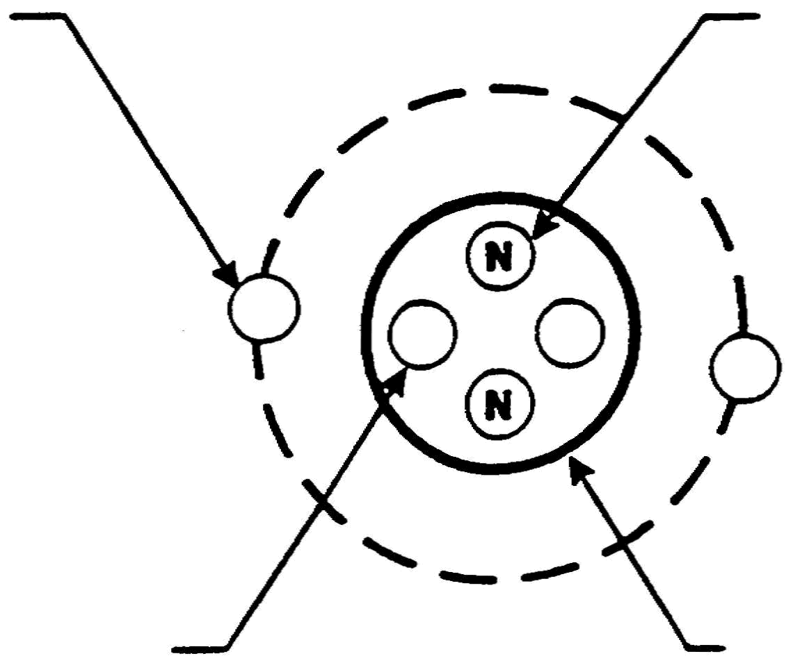
a._________ c.___________

b._______________ d. ____________

a. Electron(-)  b. Proton (+)  c. Neutron(n)  d. Nucleus(+) | 3. Match each term in column A with its definition in column B.  A B  ____(1) Molecule. a. The smallest particle of an element that retains the identity of the element.  ____(2) Element.  b. A substance that cannot be broken down  ____(3) Atom. into a simpler substance by any chemical means.  c. The smallest particle of a substance that retains the characteristics of the substance.

IT0341 1-4

(1) a.  (2) b.  (3) c. | 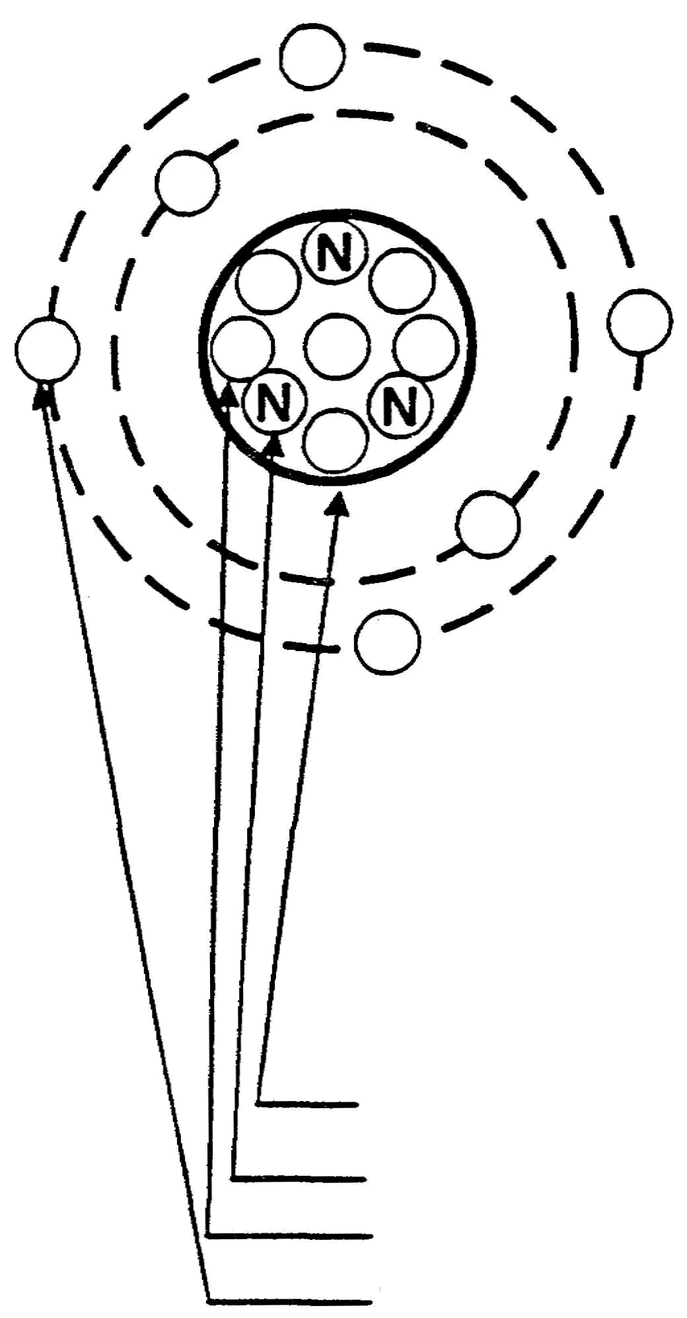  4. Label the four parts of the atom illustrated below, and indicate the charge of each as positive (+), negative (-), or neutral (n).  a.__________________ _________  b.__________________ _________  c.__________________ _________  d.__________________ _________

1-5 IT0341

a. Nucleus (+)  b. Neutron (n)  c. Proton (+)  d. Electron (-) | 5. The electrons of an atom orbit the nucleus in concentric rings or energy levels, and their exact number and arrangement determine how the atom will combine with atoms of other elements. As illustrated below, the energy level nearest the nucleus is called the K shell. The remaining shells follow in alphabetical order up to a maximum of seven energy levels.  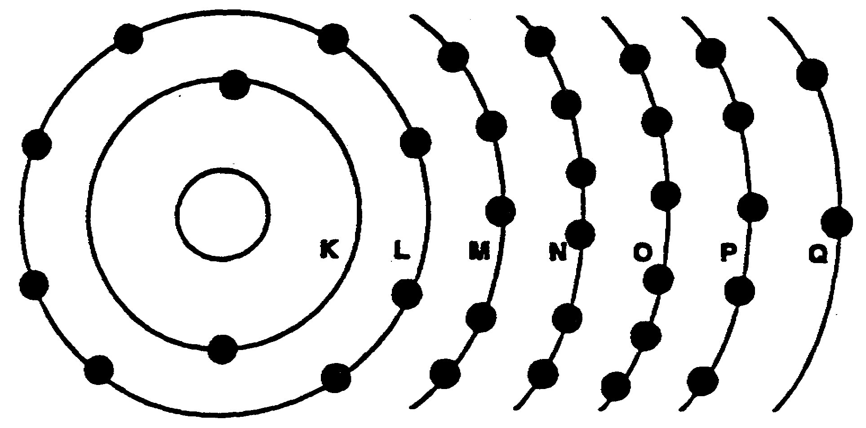  The greatest number of electrons that can exist in any level is equal to  two times the shell number squared:  No. = 2 (shell number²)  To determine the maximum number of electrons in the second, or L, shell, simply square the number of the shell and multiply that value by 2:  No. =2 (2²)

IT0341 1-6

5. (Continued)

No. = 2(4)

No. =8

Therefore, the maximum number of electrons that can exist in the second, or L, shell is eight.
Compute the maximum number of electrons that can exist in the fourth,
or N, shell.

No. =
32 | 6. The electrons in each main shell around the nucleus of an atom are further divided into subshells, as illustrated below.  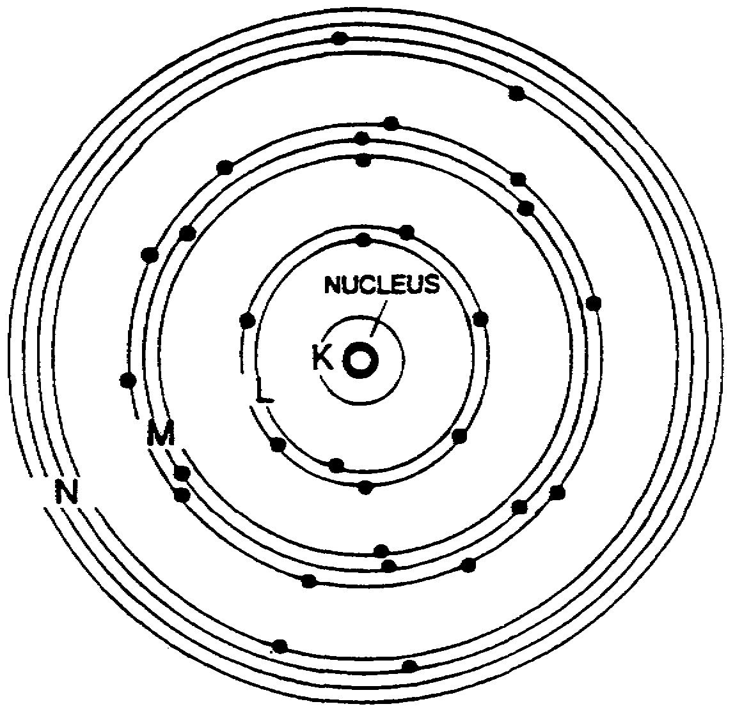

1-7 IT0341

6. (Continued)

Each main shell contains the same number of subshells as the main shell number. The first main shell, or the K shell, has one subshell, as illustrated in the diagram below.

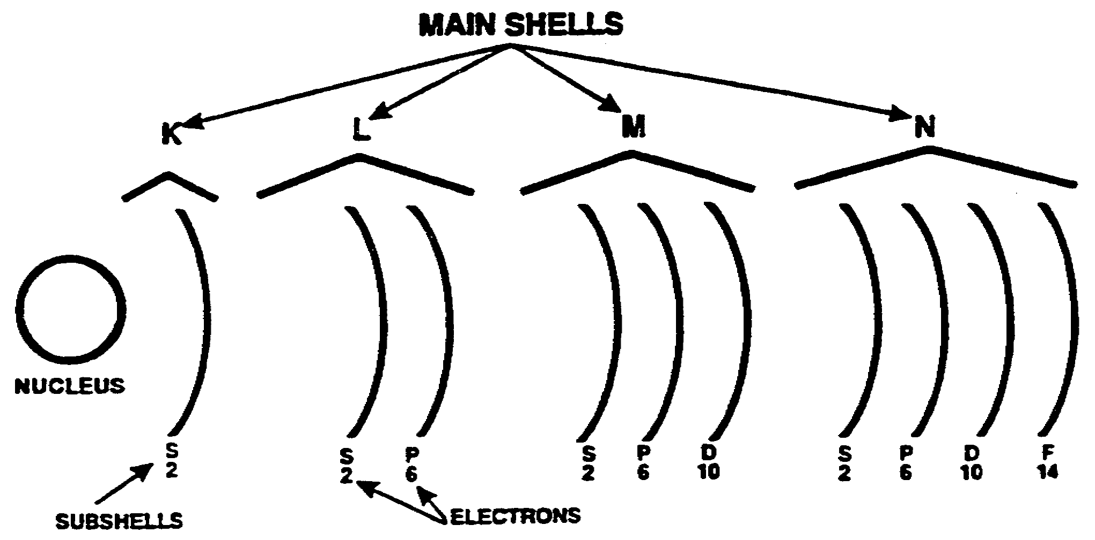

ELECTRON DISTRIBUTION IN SUBSHELLS

The second, or L, shell contains two subshells; the third shell contains three subshells, and so on. Beneath each subshell shown in the diagram above, there is a numeral indicating the maximum number of electrons possible for each subshell. Notice that the maximum total number of electrons in the subshells of any main shell is equal to the maximum number possible for that main shell.
The maximum number of subshells within each main shell of an atom is
equal to the _______________________________ number.

IT0341 1-8

main shell | 7. Calculate the maximum number of electrons in the third, or M, shell.  a. 32  b. 18  c. 2  d. 8
b. | 8. The number of protons in the nucleus of every atom of any element is constant and provides an identification called the atomic number. In an electrically balanced atom, as shown below,  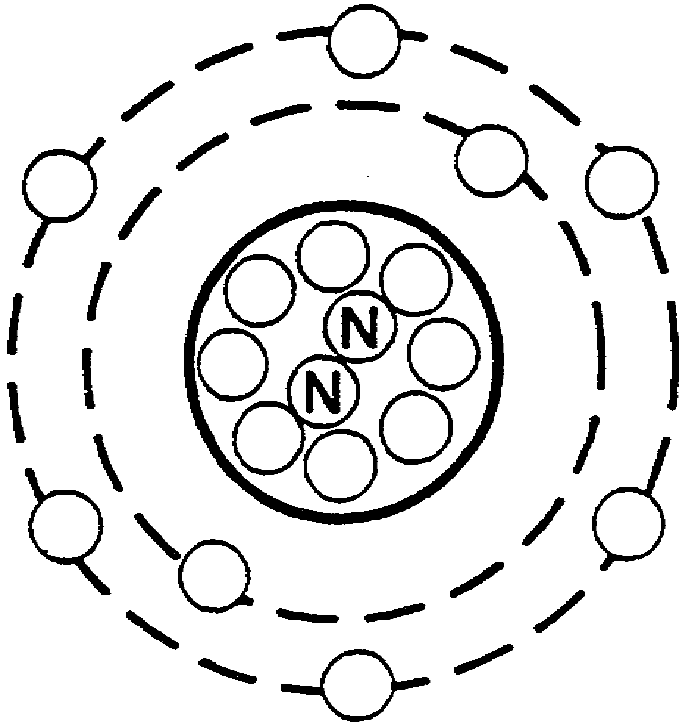  the number of protons equals the number of electrons; therefore, the number of electrons can also be used to determine the atomic number.  The atomic number of an atom is equal to the number of ________________ in the nucleus.

1-9 IT0341

protons | 9. Many characteristics of and relationships between the atoms have been incorporated into what is called the periodic chart, as shown on Page 1-39. For each of the known elements, an abbreviation called the atomic symbol is given on its block in the periodic chart. As can be seen in the section of the periodic chart below, the atomic symbol for carbon is C, and the atomic symbol for aluminum is Al.  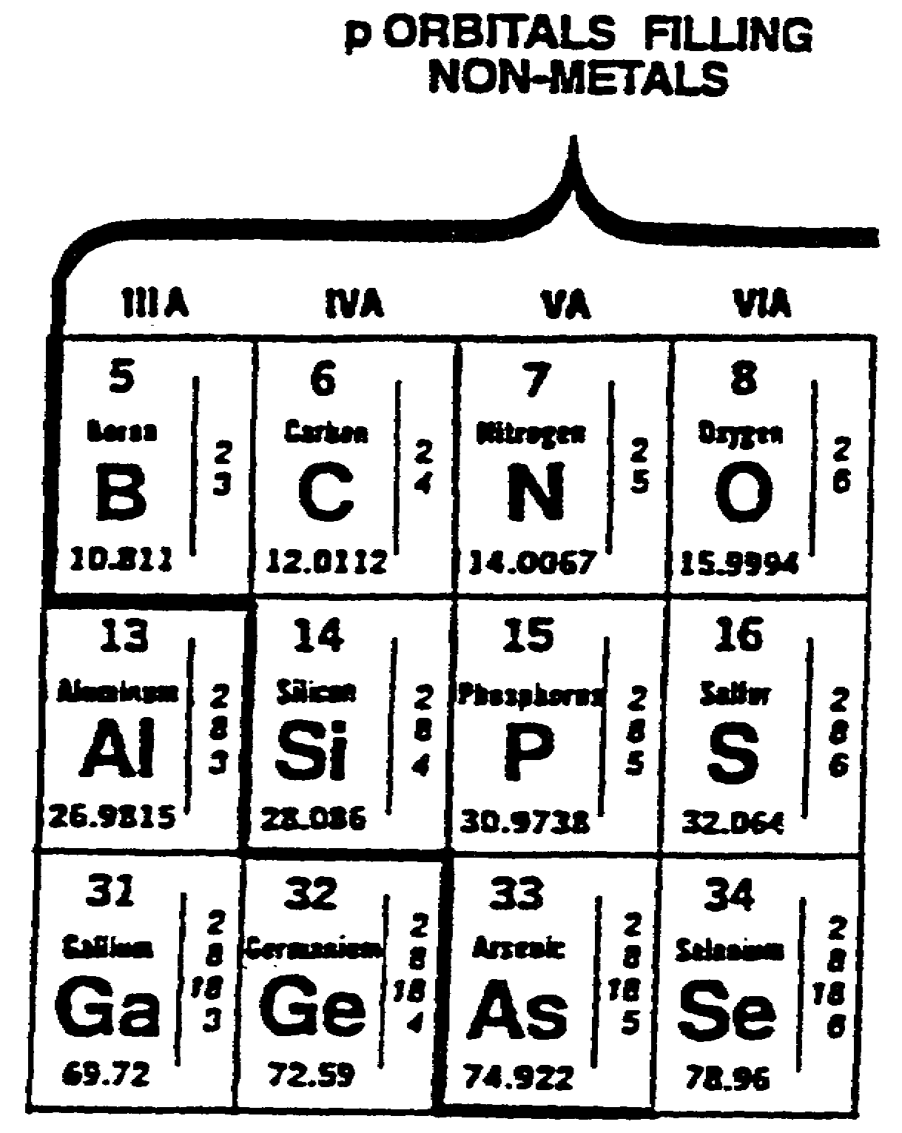  Si is the _____________ ___________________ for the element silicon.

IT0341 1-10

atomic symbol | 10. The electrons in an atom orbit the nucleus in concentric shells. Valence electrons are the electrons which can be lost or shared to form chemical bonds. In general, the bonding, or valence, electrons are located in the outermost main shell of the atom. Thus, the electrons in the outermost shell are called valence electrons, and the outermost shell is called the valence shell. The outermost shell, or valence shell, can contain a maximum of eight electrons. Most atoms have less than eight electrons in their valence shells and combine with other atoms by gaining, losing, or sharing electrons to form molecules or compounds.  Match each term in column A with its definition in column B.  A B  (1) Atomic number. a. The electrons in the outermost shell.  (2) Atomic symbol.  b. The number of protons in  (3) Valence shell the nucleus.  (4) Valence electrons c. The abbreviation for each element.  d. The outermost main shell.  e. The outermost subshell.

1-11 IT0341

(1) b.  (2) c.  (3) d.  (4) a. | 11. The maximum number of subshells within each main shell of an atom is equal to  a. the main shell number squared.  b. (n²) +1.  c. 2(N²).  d. the main shell number.
d. | 12. Determine the maximum number of electrons in the third, or M, shell of an atom.  No. = ____________________
18 | 3. The periodic chart on Page 1-39 shows each element positioned to lie in both a vertical and a horizontal row. Each of the vertical columns is headed with a Roman numeral that indicates the number of valence electrons, while each of the seven horizontal rows is preceded by a heavy Arabic numeral that indicates the number of electron shells.

IT0341 1-12

13. (Continued)

NOTE: Determination of the number of valence electrons for all elements is not possible with only the periodic chart. For any element referred to in this program, however, the number of valence electrons can be found by using the method described on the pervious page.

The element oxygen is in group VI and period 2; thus, it has six valence electrons and two electron shells. Carbon has __________________
_______
valence electrons and _____________________ electron shells.
four  two | 14. All the elements on the periodic chart are arranged in the order of their atomic number, on each block on the chart. As shown in the section of periodic chart below, the atomic number of magnesium is 12.  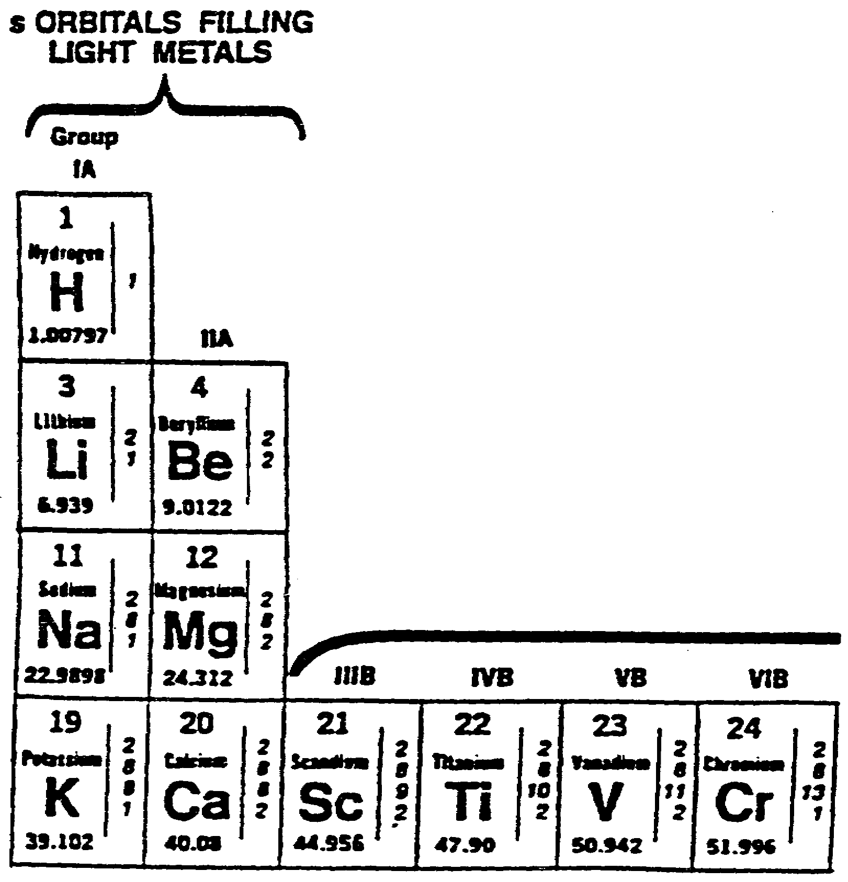

1-13 IT0341

14. (Continued)
The elements increase in atomic number from the left side of the chart to the right Notice that the element hydrogen is assigned the atomic number of 1. The atomic number of calcium is _________ .

20 | 15. Match each term in column A with its definition in column B.  A B  _____(1) Valence electrons. a. The outermost subshell.  _____(2) Valence shell. b. The outermost main shell.  _____(3) Atomic symbol. c. The abbreviation for each element.  _____(4) Atomic number. d. The number of protons in the nucleus.  e. The electrons in the outermost shell.
(1) e  (2) b.  (3) c.  (4) d. | 16. State the maximum number of subshells within each main shell of an atom.

IT0341 1-14

The number of subshells within each main shell is equal to the main shell number. | 17. Using the periodic chart on Page 1-39, determine the following characteristics for the element arsenic:  a. Atomic symbol.  b. The atomic number.  c. The number of valence electrons.  d. The number of electron shells.
a. As  b. 33  c. 5  d. 4 | 18. Match each term in column A with its definition in column B.  A B  ____ (1) Atomic number. a. The number of electrons in the nucleus.  ____ (2) Atomic symbol. b. The abbreviation for each element.  ____ (3) Valence shell.  c. The outermost main shell.  ____ (4) Valence electrons.  d. The electrons in the outer-most shell.  e. The number of protons in the nucleus.
(1) e.  (2) b.  (3) c.  (4) d. | 19. Using the periodic chart on Page 1-39, determine the following characteristics of the element argon.  a. The atomic symbol.  b. The atomic number.  c. The number of electron shells.  d. The number of valence electrons.

1-15 IT0341

a. Ar  b. 18  c. 3  d. 8 | 20. While the number of electrons possessed by an atom can be altered by heat, light, an electric field, or bombardment, the maximum chemical stability occurs when the valence shell of the atom contains a maximum number of electrons. Each main shell has a maximum number of electrons possible, determined by the formula No = 2(N2); however, if the main shell is the outermost shell, it is limited to eight electrons.  As shown on the periodic chart, sodium has one valence electron; and argon, eight. Sodium reacts violently with water, while argon, under ordinary conditions, does not form compounds with the other elements.  Helium, neon, argon, krypton, xenon, and radon (group VIII on the periodic chart) are called inert elements, because the atoms of each have complete valence shells and are considered to be the most stable atoms.  The requirement for chemical stability of an atom is that the valence shell  must contain its ______________________ number of electrons.  (maximum/minimum)

IT0341 1-16

maximum | 21. There are three types of chemical bonding-ionic, covalent, and metallic-all of which are closely associated with the outermost electrons of the participating atoms. Ionic bonding occurs when one atom gives up an electron that is used by the other to achieve chemical stability, as shown below.  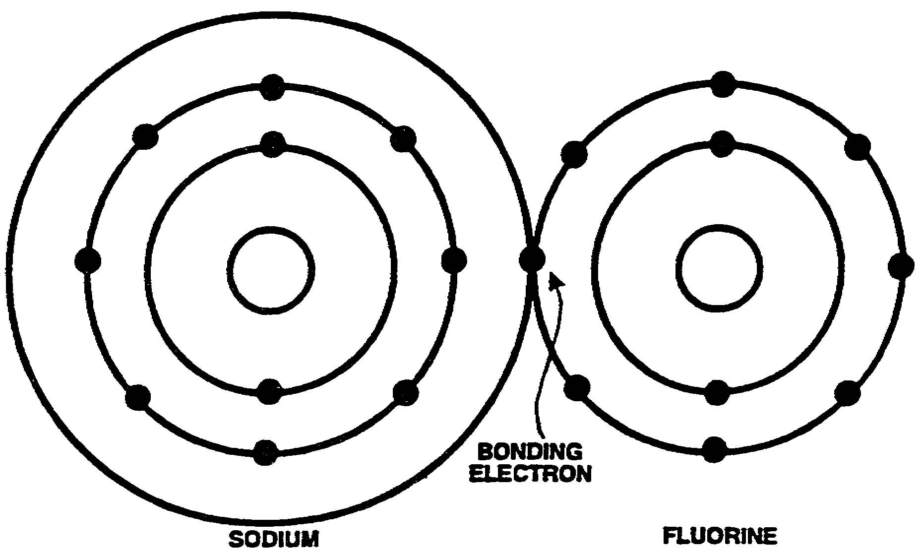  When brought into close proximity with fluorine, which contains seven valence electrons, the sodium atom allows its one valence electron to be used by the seven valence electrons of the fluorine atom. After the bonding has taken place, both atoms appear to have the eight valence electrons required for chemical stability. When an atom gives up or takes on additional electrons, it is called an ion, from which the name "ionic bonding" is derived.

1-17 IT0341

21. (Continued)
When one atom gives up an electron that is used by another atom to complete its valence shell, ____________________ bonding has taken place.
ionic | 22. Covalent bonding occurs when atoms "share" electrons in order to achieve  chemical stablity. In a germanium crystal, for example, the
the four valence electrons of a germanium atom need four more electrons to possess the eight
required for stability. As shown below, each germanium atom shares one electron with each of
its four neighboring atoms.
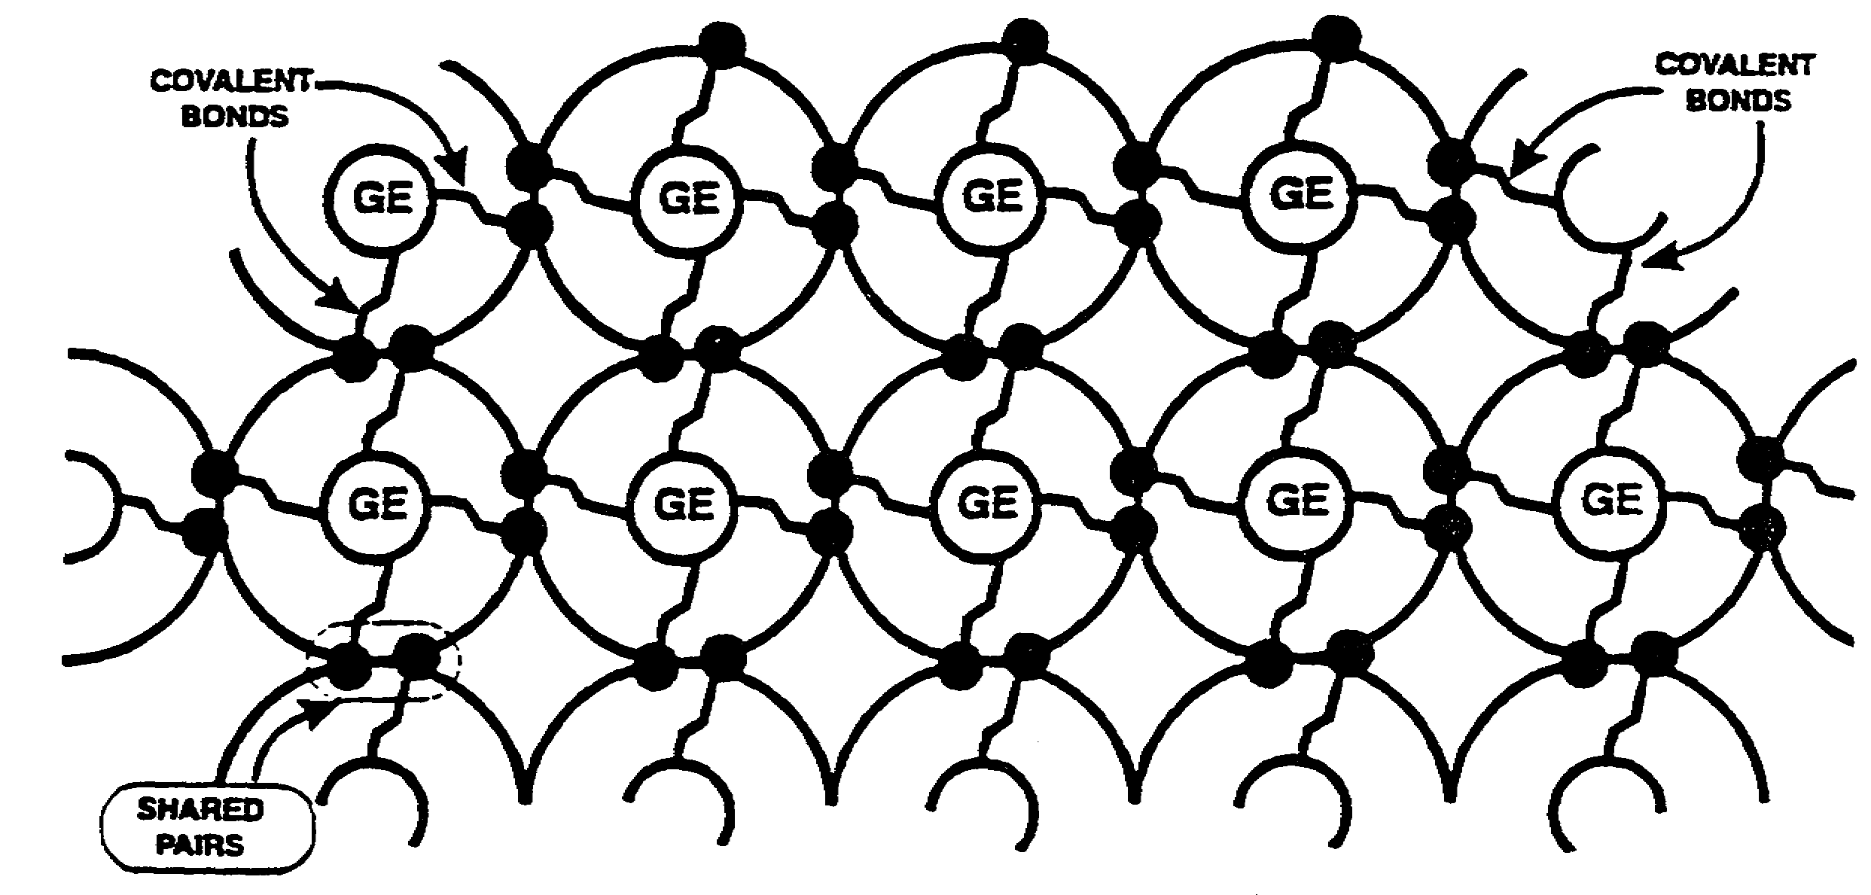
This sharing process continues throughout the crystal until all the atoms appear to have eight valence electrons.

IT0341 1-18

22 (Continued)

Covalent bonding occurs when chemical stability is made possible by
atoms ____________________ valence electrons.

sharing | 23. Metallic bonding is the continual exchange of valence electrons between several atoms, so that all the participating atoms appear to have the eight valence electrons required for stability. The atoms of metallic substances are closely packed together. In most metals, as many as twelve atoms surround each atom. The valence electrons of all these atoms are loosely held and continually being exchanged. The exchange process produces an attraction between like atoms in a metal. Although similar to the covalent bond, the metallic bonding is mobile electrons being shared by two or more atoms simultaneously.  In metallic bonding, chemical stability is achieved by the continual  ________________ of valence electrons between ________________ atoms.

1-19 IT0341

exchange  several | 24. Select the requirement for chemical stability of an atom.  a. All electron shells must be complete.  b. The valence shell must contain its maximum number of electrons.  c. The number of electrons must equal the number of protons in the  nucleus.  d. The number of electrons must equal the number of subshells.
b. | 25. Atoms, in general, are electrically more stable as the number of their valence electrons approaches eight. When an atom has less than four valence electrons, it will easily give them up for conduction; therefore, it is said to be a conductor. Copper, gold, and silver, considered to be among the best conductors, have atoms with one valence electron each. Atoms with more than four valence electrons do not easily give up electrons for conduction and are referred to an insulators. Atoms, such as in germanium and silicon, that contain exactly four valence electrons are called semiconductors.

IT0341 1-20

25. (Continued)

Match each term in column A with its definition in column B.

A B

_____ (1) Conductor. a. Elements whose atoms have four valence electrons.
_____ (2) Insulator.
b. Elements whose atoms have more
_____ (3) Semiconductor. than four valence electrons.

c. Elements whose atoms have complete "L" shells.

d. Elements whose atoms have less than four valence electrons.

(1) d.  (2) b.  (3) a. | 26. Match each term in column A with its definition in column B.  A B  _____ (1) Ionic bonding. a. The continual exchange of valence electrons between several atoms.  _____ (2) Covalent bonding.  b. Occurs when atoms share electrons  _____ (3) Metallic bonding. in order to achieve chemical stability.  c. Occurs when one atom gives up an electron that is used by another atom to achieve chemical stability.

1-21 IT0341

(1) c.  (2) b.  (3 a. | 27. State the requirements for chemical stability of an atom.
The valence temperature shell must contain its maximum number of electrons. | 28. Almost every conductor material possesses a POSITIVE coefficient of resistance; that is, the resistance of the conductor INCREASES as temperature INCREASES. Temperature can change the total number of electrons available for conduction, and it can change their average speed of motion in an electric field. A conductor is an element whose atoms have from one to three valence electrons (see copper on the periodic chart). Since a!! the valence electrons of such materials are used in the conduction of current, the total number of electrons for conduction cannot be appreciably changed. The dominant effect, then, is the scattering of the current-carrying electrons by collision with atoms of the crystal. This means that the average velocity of the electrons used for conduction decreases as the temperature increases.  Thus, the resistance increases as the temperature increases, which shows a positive temperature coefficient of resistance.

IT0341 1-22

28. (Continued)

When the temperature of a conductor material increases, the resistance

__________________ .
(increases/decreases)

increases | 29. Match each term in column A with its definition in column B.  A B  _____ (1) Conductor. a. Elements whose atoms have exactly four valence electrons.  _____ (2) Semiconductor  b. Elements whose atoms have more  _____ (3) Insulator. than four valence electrons.  c. Elements whose atoms have a complete 'L shell.  d. Elements whose atoms have less than four valence electrons.

1-23 IT0341

(1) d.  (2) a.  (3) b. | 30. Match each term in column A with its definition in column B.  A B  _____ (1) Ionic bonding. a. Occurs when atoms share electrons in order to achieve chemical  _____ (2) Covalent bonding. stability.  _____ (3) Metallic bonding. b. Occurs when one atom gives up an electron that is used by another atom to achieve chemical stability.  c. the continual exchange of valence electrons between several atoms.
(1) b.  (2) a.  (3) c. | 31. Almost all semiconductor materials possess a NEGATIVE temperature coefficient of resistance, which means that the resistance DECREASES as the temperature increases. There are two ways in which an increase in temperature can affect the interaction of the electrons of a solid within an external electric field. Specifically, temperature can change the total number of electrons available for conduction, and it can change the average speed of motion of the electrons in the electric field. Semiconductors are elements possessing four valence electrons (see germanium on the periodic chart). Such elements give up more of the valence electrons for conduction when they undergo an increase in

IT0341 1-24

31. (Continued)

temperature; thus, their resistance decreases.

When a semiconductor material undergoes an increase in temperature,
its resistance ______________________ .

decreases | 32. Select the effect that an increase in temperature has on the resistance of a conductor material.  a. Resistance increases.  b. Resistance decreases.  c. Resistance remains the same.
a. | 33. Match each term in column A with its definition in column B.  A B  _____ (1) Conductor. a. Elements whose atoms have exactly four valence electrons.  _____ (2) Semiconductor.  b. Elements whose atoms have  _____ (3) Insulator. complete "L" shells.  c. Elements whose atoms have less than four valence electrons.  d. Elements whose atoms have more than four valence electrons.

1-25 IT0341

(1) c.  (2) a.  (3) d. | 34. Select the effect that an increase in temperature has on the resistance of a semiconductor material.  a. Resistance increases.  b. Resistance decreases.  c. Resistance remains the same.
b. | 35. State the effect that an increase in temperature has on the resistance of a conductor material.
Resistance increases. | 36. State the effect that an increase in temperature has on the resistance of a semiconductor material.

IT0341 1-26

Resistance  Decreases. | 37. A large number of elements exist in two or more forms called isotopes. decreases All the atoms of an element share the common feature of having the same number of protons; thus, they all have the same atomic number. The isotopes, or different forms of the same element, differ only by the number of neutrons in the nucleus. The element hydrogen has three isotopes, which are shown below.  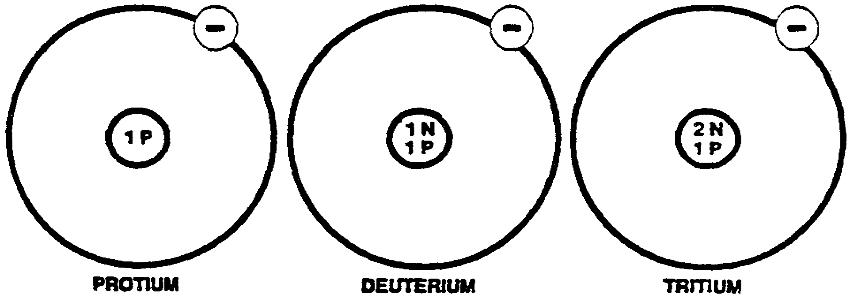  Since the protons and the neutrons make up the largest part of the atom, each of the different isotopes of an element has a different atomic mass. Each of the three isotopes of the element hydrogen differs in mass by the mass of one neutron.  Isotopes are different forms of an element, each having a different atomic  ___________________ ,

1-27 IT0341

mass | 38. The atoms of all isotopes of any one element have the same number of protons. This number is called the atomic number and is a characteristic of the element The nuclei of the different isotopes differ in the number of neutrons. The ATOMIC MASS NUMBER is the sum of the protons and neutrons of the nucleus. Atoms of the different isotopic forms are distinguished by using the mass number as a superscript to the atomic symbol. Thus, C¹² refers to the carbon isotope of mass number 12.  The mass number of an atom is the sum of the _____________________ and the _____________ of the nucleus.
Protons  neutrons | 39. The masses of the individual atoms are very small, the greatest being neutrons only 5 x 10²² grams. To reduce the complexity in computations involving atomic masses, the atomic mass unit (AMU) was adopted. The atomic mass unit is equal to one-twelfth the mass of a carbon atom. (C¹² is used for this reference, because it is the most abundant carbon isotope.) According to this standard, the carbon atom has a mass of 12 atomic mass units.

IT0341 1-28

39. (Continued)

The atomic mass unit (AMU) is equal to ___________ the mass of the
(number)

____________ atom. The sum of the protons and the neutrons of the

nucleus is called ___________ ___________ ___________ .

one-twelfth  carbon  atom mass  number | 40. Most of the elements exist in several isotopic forms, each of which differs in weight by one neutron. The natural abundance of the isotopes of an element varies with the element considered. Over 98 per cent of the carbon found in the earth is the C¹² isotope. The relative atomic weight of an element is the average mass of its natural isotopic mixture. There are six isotopes of carbon, and the average of their masses is called the atomic weight of carbon. The relative atomic weight of carbon is found on the section of the periodic chart shown below.  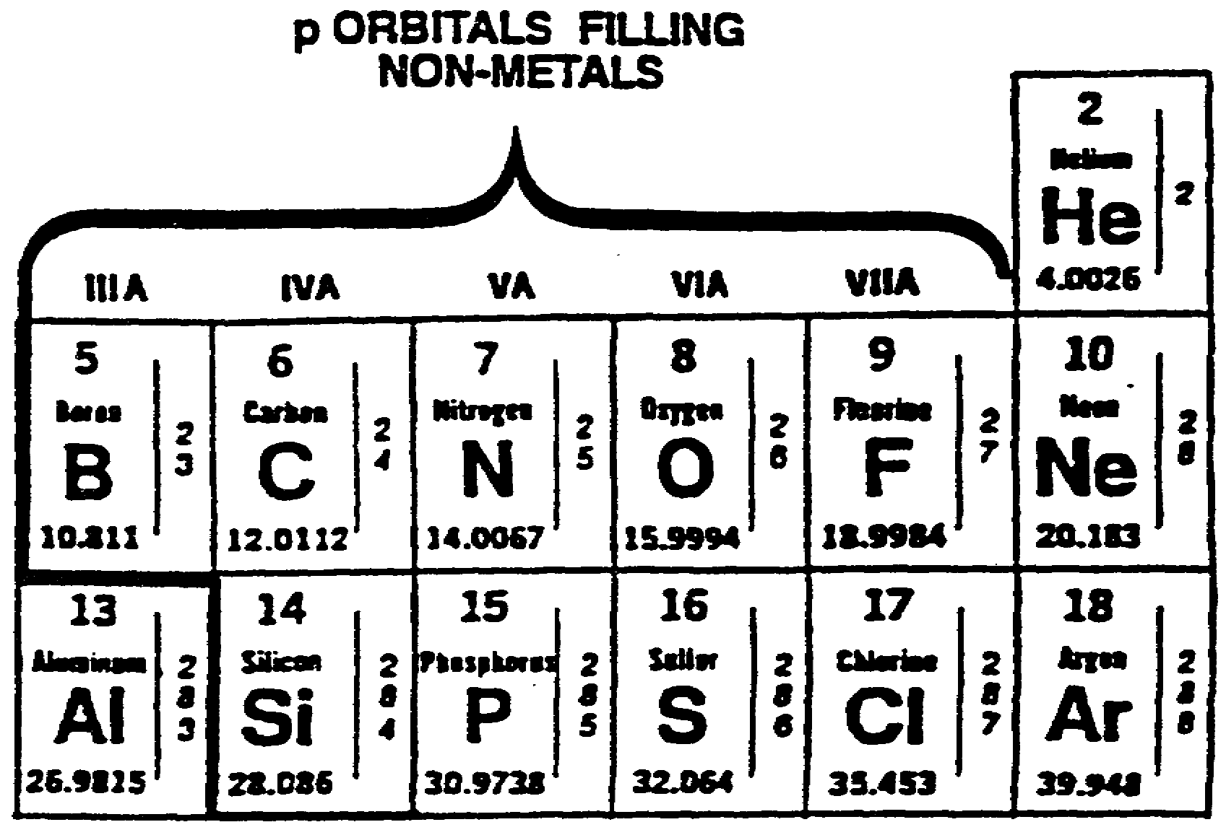

1-29 IT0341

40. (Continued)

Match each term in column A with its definition in column B.

A B

_____ (1) Mass number. a. One-twelfth the mass of a C¹² atom.

_____ (2) Atomic mass unit. b. The sum of the protons and the neutrons of the nucleus.
_____ (3) Relative atomic
weight. c. The average mass, in atomic mass units, of an atom's natural isotopic mixture.

d. The absolute mass, in atomic mass units, of the most abundant isotope of an element.

e. The sum of electrical charges within the atom.

(1) b.  (2) a.  (3) c. | 41. Select the definition of an isotope.  a. Different forms of an element, each having a different atomic mass.  b. Ionized forms of an element, each having a constant mass.  c. Atoms that have suffered a loss in atomic mass as a result of electron removal.  d. Atoms that have increased in atomic mass as a result of electron attraction.

IT0341 1-30

a. | 42. Two types of isotopes occur in nature, stable and radioactive. All the atoms of an isotope have the same number of protons in their nuclei; thus, they have the same atomic weight. Radioactive isotopes, however, are capable of emitting, or radiating, alpha particles or beta particles from their nuclei, which reduces the atomic weight. Depending on the type of particle emitted, the atomic number may also be reduced. When such radiation occurs, the original element is changed into another element of lower atomic weight. The reduction in mass of the atom releases energy in the form of gamma radiation. Since the radioactive isotopes emit particles, they are in a constant state of disintegration.  The two types of isotopes occurring in nature are ___________________ and ________________________ .

1-31 IT0341

radioactive  stable | 43. Match each tem in column A with its definition in column B.  A B  _____ (1) Mass number. a. The sum of electrical charges within the atom.  _____ (2) Atomic mass unit.  b. The absolute mass, in  _____ (3) Relative atomic weight atomic mass units, of the most abundant isotope of an element.  c. The average mass, in atomic mass units, of an atom's natural isotopic  d. The sum of the protons and the neutrons of the nucleus.  e. One-twelfth the mass of a C¹² atom.
(1) d.  (2) e.  (3) c. | 44. State the definition of an isotope.

IT0341 1-32

Different forms of an element, each having a different atomic mass. | 45. Radioactive substances undergo a constant disintegration process. The entire mass of a sample of radioactive material does not disintegrate simultaneously. Relatively few of the great number of nuclei present in an ordinary sample will disintegrate in any small-time interval. The term 'half life' is used to indicate the time required for half of the number of radioactive atoms initially present to disintegrate. When the half life of uranium 234 is said to be 269,000 years, this means that, on the average, half of the atoms of uranium present in a given sample will disintegrate in 269,000 years and half of the remaining atoms will disintegrate by half in the next 269,000 years. The half life of a radioactive element varies form element to element, ranging from 14 billion years for thorium 232 to a fraction of a second for polonium 212. Stating the half life is a way of indicating the rate at which the nuclei of a radioactive element will disintegrate.  The half life of a radioactive element is the time required for  ___________________________________________________________ .

1-33 IT0341

half of the number of radioactive atoms to disintegrate. | 46. Select the two types of isotopes occurring in nature.  a. Normal and abnormal.  b. Natural and artificial.  c. Alpha particles and beta particles.  d. Stable and radioactive.
d. | 47. Match each term in column A with its definition in column B.  A B  _____ (1) Mass number. a. One-twelfth the mass of a C¹² atom.  _____ (2) Atomic mass unit. b. The sum of electrical charges within the atom.  _____ (3) Relative atomic  weight c. The absolute mass, in atomic mass units, of the most abundant isotope of an element  d. The sum of the protons and the neutrons of the nucleus.  e. The average mass, in atomic mass units, of an atom's natural isotopic i-mixture.

IT0341 1-34

(1) d.  (2) a.  (3) e. | 48. The mass of a nucleus is always less than its constituent particles by an amount called the mass defect The mass of a helium nucleus is 4.000 AMU but the mass of its two neutrons and two protons is 4.033 AMU. This leaves a difference of 0.033 AMU. According to the Einstein relation E = mc², the loss in mass (m) measured in grams must appear as energy released as a result of a reaction. The difference of 0.033 AMU between the mass of the helium nucleus and the mass of its constituent particles, which is the amount of mass converted into energy to bind the nucleus, is called the mass defect.  Mass defect is the difference between the mass of the_______________ and the mass of its _________________________ particles.
nucleus  constituent | 49. Select the definition of half life.  a. The time required for all radioactive atoms to disintegrate.  b. The time required for half of the protons of an atom to depart a radioactive atom.  c. The time required for half of the number of radioactive atoms to disintegrate.  d. The time required for all the protons of an atom to depart from a radioactive atom.

1-35 IT0341

c. | 50. List two types of isotopes occurring in nature.  (1)  (2)
Stable.  Radioactive. | 51. Three types of changes take place in matter-physical, chemical, and nuclear. A physical change is a change of state, and the composition of the substance is not altered. The change from water to ice is a physical change, as there is no change in the arrangement of the atoms. Chemical changes are characterized by a rearrangement of the electron structure, which produces a new substance. The combination of iron and oxygen to form the new substance, iron oxide (rust), is an example of a chemical change. When a nuclear change occurs, atoms of one element are changed to atoms of another element. The gradual change of radium atoms to lead atoms is a nuclear change.  The three types of changes that take place in matter are physical,  __________________, and ____________________ .

IT0341 1-36

chemical  nuclear | 52. Select a statement which describes mass defect.  a. The mass of the nucleus of an atom after a period of radioactive disintegration.  b. The difference between the mass of the nucleus and the mass of its constituent particles.  c. The mass of an atom lost in radioactive disintegration.
b. | 53. State the definition of half life.
The time re-quired for half of the number of radioactive atoms to disintegrate. | 54. Select the three types of changes that take place in matter.  a. Chemical, natural, and artificial.  b. Chemical, physical, and artificial.  c. Physical, chemical, and nuclear.  d. Chemical, nuclear, and radioactive.

1-37 IT0341

c. | 55. Select a statement describing mass defect.  a. The portion of the mass of particles of the nucleus given up to binding energy.  b. The mass of the nucleus of an-atom after a period of radioactive decay.  c. The mass of an atom lost in radioactive disintegration.
a. | 56. List the three types of changes that take place in matter.  (1)  (2)  (3)
Physical
chemical
Nuclear
 | You have completed the text of this subcourse. Review the objectives on pages i and ii, and make sure you understand them. When you are ready, complete the examination, which begins on Page E-1.

.

IT0341 1-38

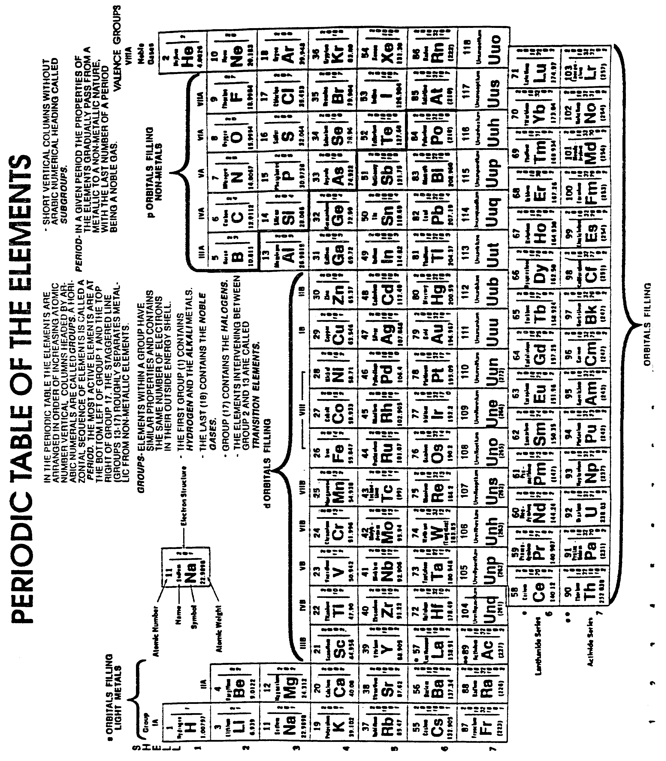

1-39 IT0341

